Today meeting

26-7-2015

first : converting ac to dc 12 v & 5v

Using :

1- transformer 12v & 24 v

2- rectifier

3- IC regulator ( 7805)

4- capacitor 470 MF
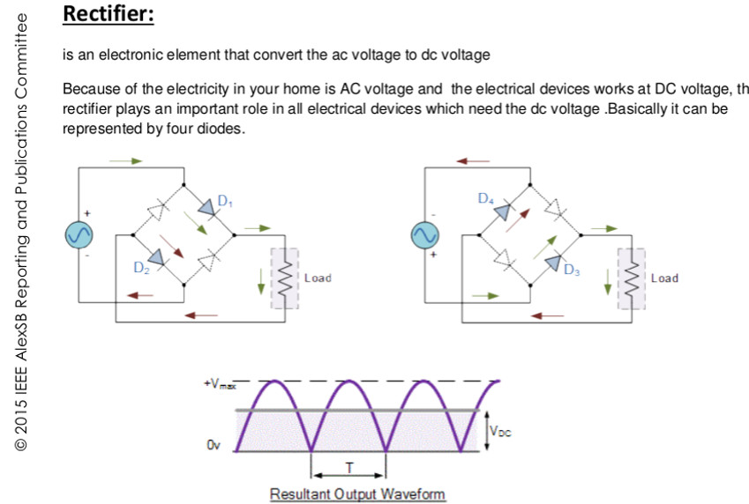

after testing ,
searching for several ways to make entrance sensors for garage : “PIR not Bad “
searching for temperature sensor finding “ dht11 , lm35 , LM 36 “
searching for Limit Switch for garage “ enter the garage “
Home task :
1st garage :
control DC motor
PWM control DC
PIR data sheet
Limit switch “ how to put it in Marketa “
coding
@ Electra : writing the code
makes connections and semantic on bread board as Trial
Testing

2nd Temperature sensors :
searching for temp sensors and how does it work “ data-sheet & interacting with arduino “
- how to connected via arduino and fan “ coding”

@ Electra :

Writing the code
make connections & schematics on breadboard “as a trial “
Testing ,

Tomorrow @ Electra @ 3:00 PM
3rd Meeting

